|  |  |  |  |  |  |  |  |  |
| --- | --- | --- | --- | --- | --- | --- | --- | --- |
| **TITLE** | PROCEDURE FOR LIFTING OPERATIONS | | | | **PAGE NO.** | | | **1**of **18** |
| **REVISION NO.** | | | 00 |
| **SOP NO.** | KAL-ENG-SOP-56 | | | | | | | |
| **EFFECTIVE DATE** | FEBRUARY 2018 | | **DEPARTMENT** | ENG | **RELATED DOCUMENTS** | | | SEE LIST ATTACHED |
| **REVIEW DATE** | FEBRUARY 2019 | | **DISTRIBUTION LIST** | | | ALL KMM EMPLOYEES AND CONTRACTORS |
| **SIGNATURES** | | | | | | | | |
| **COMPILED BY** | | | **FUNCTIONAL RESP.** | | | **AUTHORISED BY** | | |
|  | | |  | | |  | | |
|  | | |  | | |  | | |
|  | | |  | | |  | | |
|  | | |  | | |  | | |
|  | | | | | | | | |
| **ACKNOWLEDGEMENT BY** | | | | | | | | |
|  | |  | | | | |  | |
|  | |  | | | | |  | |
|  | |  | | | | |  | |
|  | | | | | | | | |

**APPROVAL SIGNATURES:**

|  |  |  |  |
| --- | --- | --- | --- |
| **NAME & SURNAME** | **DESIGNATION** | **SIGNATURE** | **DATE** |
|  |  |  |  |
|  |  |  |  |
|  |  |  |  |
|  |  |  |  |
|  |  |  |  |
|  |  |  |  |
|  |  |  |  |

TABLE CONTENTS

1. Objective 2
2. Introduction 2
3. Control documentations 5
4. Basic Safety rules 7
5. Suspension of persons by crane 12
6. Suspension of person(s) by Manitou 13
7. FCR Compliance on Equipment 13
8. Equipment’s 13
9. Modifications 14

10.0 Crane or Manitou Maintenance 14

11.0 Lifting Equipment maintenance 14

12.0 Incident Investigation 15

13.0 Plan Task Observation 15

14.0 Training and Competency 16

15.0 Purchasing 16

16.0 Monitoring and Audits 17

17.0 Responsibility 17

18.0 Recovery Plan 19

19.0 Precaution to observe when working with slings 20

Appendix 1.0 Pre-Start checklist 21

Appendix 2.0 Pre-Start Manitou 22

Appendix3.0 Pre-used Checklist Main Cage 23

Appendix 4.0 Mobile Crane compliance Checklist 24

Appendix 5.0 Manitou Compliance checklist 26

Appendix 6.0 Lifting and Rigging Plan 28

Appendix 7.0 FCR Machine Specification 32

Appendix 8.0 Overhead Crane pre-used Checklist 35

Appendix 9.0 Hand Signals for Hoisting operations 37

Appendix 10.0 Definitions and Abbreviations 38

Appendix 11.0 Documentation Revision Control 39

Appendix 12.0 References 39

1. **Objective and Scope**

The purpose of this procedure is to eliminate damage to property or plant as well as to eliminate potential harm to all employees, contractors and visitors on Kalagadi Mine controlled work sites resulting from Lifting Operations

This Procedure applies to **lifting operations** involving company owned, hired or contracted equipment including cranes, Manitou’s or Elevated Work Platforms (EWP’s) that can lower or suspend a load or people.

This Procedure also applies to all dedicated **lifting equipment** on Kalagadi Mine controlled work sites. The requirements described in this procedure have been developed to meet the following points:

* 1. Ensure documentation generated is standardized, and equipment depicted complies with legislative requirements’ in accordance to the Mines Health and Safety Act (Act 29 of 1996) and regulations (as amended) and or Occupational Health and Safety Act (Act 85 of 1993) and regulations (as amended
  2. Ensure equipment referenced within documentation is in accordance to agreed standardized equipment list/s and are manufactured in accordance to the South African Bureau of Standards (SABS) criteria set out with the appropriate South African National Standard (SANS), as a minimum requirements; not neglecting any of the afore mentioned requirements

1. **Introduction**

The procedure requires that a system of work for the use of Cranes or Manitou’s and other lifting equipment is established and maintained. This is all achieved by ensuring that:

* 1. Lifting operations are adequately assessed, regarding their risk
  2. ALL lifting equipment is inspected and safe for use.
  3. Personnel involve for lifting must have necessary skills, experience and competence skills to perform such lifting safely.
  4. Personnel involved in lifting tackle should have basic rigging course training.

1. **Controlled Documents** 
   1. **Documents Required before lifting**

|  |  |  |
| --- | --- | --- |
| No | Action | Responsibility |
| 1 | Effective work planning and Risk assessment processes are essential to the safe execution for all lifting activities | Rigger |
| 2 | All Risk Assessment are in line with Kalagadi HSEC Risk Management Guideline and follow the Hierarchy of Controls | Rigger |
| 3 | 3.1.3 For any work activity that requires lifting operations, there will be a clearly defined Scope of Work, documented in the Risk Assessment | Rigger |
| 4 | 3.1.4 All lifts greater than five (5) tons require a Lifting Operation permit to work over and above the Risk Assessment. This includes lifting from above, pushing from below (jacking) or in any direction | Rigger |

* 1. **Complex Lift**

|  |  |  |
| --- | --- | --- |
| No | Action | Responsibility |
| 1 | 3.2.1 All Complex lifts require an additional lifting plan (Appendices 6.0) over and above the Risk Assessment and permit to work mentioned above. Complex lifts include any high-risk lifting activity such as using more than one lifting device simultaneously and | Rigger |
| 2 | 3.2.2 The load mass is 80 percent or more of the rated capacity of the crane. | Rigger |
| 3 | 3.2.3 The load to be lifted is swung or placed out of the operators view. | Rigger |
| 4 | Using more than one crane | Rigger |
| 5 | The arcs of operation of two or more cranes can overlap | Rigger |
| 6 | Adverse environmental conditions exist such as high wind speed. | Rigger |
| 7 | Involving non-routine or technically difficult rigging arrangements. | Rigger |
| 8 | Lifting of personnel by means of a boson chair approved by engineer. | Rigger |
| 9 | Lifts involving hazardous materials or explosives | Rigger |
| 10 | Lifts involving submerged loads. | Rigger |
| 11 | Lifts where the centre of gravity of the load could change. | Rigger |
| 12 | Lifts in the proximity of electrical conductors | Rigger |
| 13 | Lifting in and out of confined spaces | Rigger |
| 14 | Lifting which requires engineering input | Rigger |
| 15 | Lifts where the crane operator assesses the lift as being a complex lift. | Rigger |
| 16 | Complex lifts can only be done under supervision of a qualified rigger. | Rigger |

* 1. **All Scope of work will be**

|  |  |  |
| --- | --- | --- |
| No | Action | Responsibility |
| 1 | Be used to determine resource requirements (personnel, PPE, materials, plant and rigging equipment etc.) and estimated time to complete the task. | All |
| 2 | Clearly defined the sequence of activities to follow during the lift. | All |
| 3 | Identify all hazards, assess the risks and implement effective controls. | All |

* 1. **Environmental Requirements**

|  |  |  |
| --- | --- | --- |
| No | Action | Responsibility |
| 1 | In the event of material spillage, particularly when a spill occurs outside of a bounded area, treat spill as per procedure using s spill kit | All |

**3.5 Basic Rules of Rigging**

|  |  |  |
| --- | --- | --- |
| No | Action | Responsibility |
| 1 | Know the weight of the load | Rigger / Assistant |
| 2 | Know how to judge distances, heights and clearances | Rigger / Assistant |
| 3 | Know the factors that reduce capacity.  Know the safe practices in rigging, lifting and landing loads. | Rigger / Assistant |
| 4 | Determine the available capacity of the lifting equipment being used. | Rigger / Assistant |
| 5 | Never exceed the lifting capacity of the lifting equipment. | Rigger / Assistant |
| 6 | Inspect the lifting equipment prior to use | Rigger / Assistant |
| 7 | Inspect all lifting equipment in his/her area of responsibility and tag accordingly. | Rigger / Assistant |
| 8 | Remove unsafe lifting equipment from service and report the defect(s) to the supervisor. | Rigger / Assistant |
| 9 | Rig the load so that it is stable | Rigger / Assistant |
| 10 | Make allowances for any unknown factors. | Rigger / Assistant |
| 11 | Lifting equipment determined to be defective need to be placed in quarantine immediately to prevent inadvertently used by someone else. | Rigger / Assistant |

**4. Basic Safety Rules When Lifting a Machine**

|  |  |  |
| --- | --- | --- |
| No | Action | Responsibility |
| 1 | Prior to selecting the set up site, check the Crane for possible interference with electric power lines or overhead hazards above. Lifting activities within 10 metres of any overhead aerial conductors will comply with the issue of an appropriate permit by the relevant Engineer. | Rigger |
| 2 | Set the Crane up so it is level with adequate and appropriate packing under the outriggers. | Rigger |
| 3 | Proper planning is required to identify the most suitable route to allow access to and egress from the intended lift work area. | Rigger |
| 4 | Consideration will be given to the lifting work area and its ability to accommodate the ground bearing pressure of the lifting machine and its load. | Rigger |
| 5 | Establish exclusion zones around the lifting machine and working area that cover the entire working area including levels below the lift and other areas where personnel may be endangered by the task. | Rigger |
| 6 | If a lifting machine is used the following personnel must be included:   * At least one operator who has experience in the use of such a machine and declared competent by virtue of his or her license. * • At least one trained, authorized and competent person who’s function is to be in charge of the lift and to give signals to the operator. | Rigger |
| 7 | If the scope of work changes during the work process the lifting operations will cease. The risk assessment must be revised to include all changes, identify new hazards, address the changed risk and put new controls in place. All work team members will re-sign onto the risk assessment or lifting plan. | Rigger |
| 8 | Prior to and during a lift, weather conditions will be considered as part of the risk assessment.   * The lifting machine will not work in wind speeds greater than 10m/s (36 km/h). * All movement will stop if communication is lost or not clear. * Heavy rain that affects the ability of persons to correctly position the load due to slippery surface will result in the crane being stopped and parked in a safe condition. * Lifting operations will not be allowed if there is a risk of lightning that can strike a raised Crane boom or load and cause damage to the Crane as well as injury to persons working on or near the Crane or load.   Any conditions with restricted vision, such as (but not limited to) sandstorm, windstorm or heavy rain, will halt the operation of the crane.   * The area surrounding any lifting operation must be properly barricaded | Rigger |
| 9 | There will be either a permanently installed wind speed meter on slew Crane or other such measuring methods such as site fixed monitoring or hand held anemometer available. | Rigger |
| 10 | Lifting machine will operate during bad weather conditions, except in medical / fire / rescue emergency situations. In such emergency situations a formal risk assessment will take place. | Rigger |
| 11 | In the event that a lift is occurring at the time of onset of bad weather, then it may be necessary to continue to have the load supported by the Crane but to withdraw all persons from the area and have the Crane operator remain in the Crane cabin but not be holding any of the Crane controls until the bad weather passes | Rigger |
| 12 | When work proceeds from one work shift to another, the handover will be done between the two shifts. The incoming crane operator will sign the crane log book prior to starting work. Pre-start checks will be done at the earliest possible opportunity (i.e. if holding a load, as soon as the load is lowered and before any other lifts commence). | Rigger |
| 13 | The need to work under suspended loads will be eliminated. | Rigger |
| 14 | The following aspects will be adhered to prior to and/or during all lifting operations:  • Cranes are only to be operated by certified competent and authorized operator.  • Cranes must be inspected before used on site.  • Crane Operators are to be isolated from the outside environment during lifting operations. This includes closing windows and doors with the intent of keeping noise and dust out of the cabin. If this is not adhered to full PPE will be worn.  • Cranes, laden or unladed will not operate or traverse unstable surfaces or gradients that are outside their design specification.  • No lifting will commence until outriggers are fully engaged. No pick and carry is allowed for any crane.  • Cranes fitted with outriggers Riwill have them locked in position by a positive means when set up.  • Cranes equipped with free-fall devices require the ability for these devices to be positively isolated to stop inadvertent free fall of the hook blocks. On some cranes these levers are in an exposed position where accidental activation is possible.(figure 1) | Rigger |

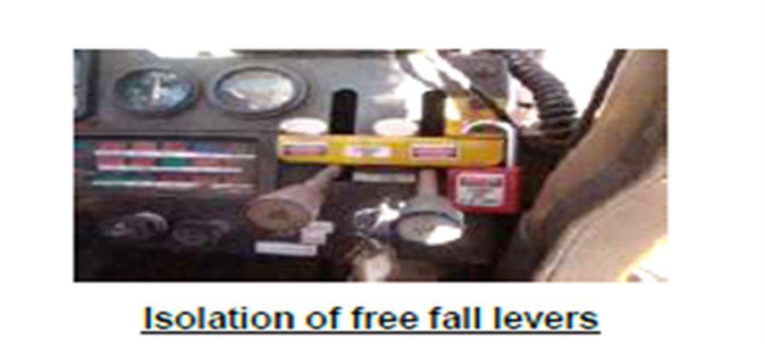

|  |  |  |
| --- | --- | --- |
| No | Action | Responsibility |
| 1 | All cranes will have a daily pre-start checklist completed prior to use every day. | Rigger |
| 2 | A crane driver will be in attendance on the crane at all times whilst a load is suspended. | Rigger |
| 3 | Crane capacity will not be exceeded at any occasion. | Rigger |
| 4 | Any multiple crane lifts will only be undertaken when all other options for single crane lifts have been evaluated and deemed not suitable. | Rigger |
| 5 | The lifting plan will be authorized by the responsible superintendent in signature. | Rigger |
| 6 | The load or hook of a crane will not be positioned or moved over another’s operating cabin, nor will a crane drive under another’s load. | Rigger |
| 7 | Any lifting points will be visually checked for suitability and integrity by the responsible rigger. | Rigger |
| 8 | Attach the rigging equipment to the load and ensure alignment of the rigging equipment is suitable. Pack the rigging equipment with suitable padding at any point where either the rigging equipment or the load can be damaged. | Rigger |
| 9 | Attach the tag lines at points that will allow the load to be controlled during the lift where required. The requirement of the use of tag lines will be identified during the Risk assessment process (figure 2 | Rigger |

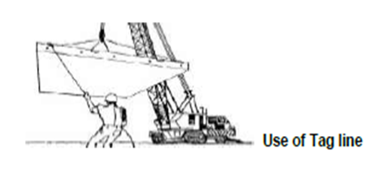

Figure 2

|  |  |  |
| --- | --- | --- |
| No | Action | Responsibility |
| 1 | Loads will not be guided by hands when suspended by the crane, but by tag lines. | Rigger |
| 2 | Clear the area under the intended hook or load path from personnel prior to and during lifting operations. All personnel that are not directly involved in the lift are to be removed from the area. | Rigger |
| 3 | Loads will not have loose items on top of them. All items to be lifted will be secured by appropriate means | Rigger |
| 4 | Loads will not have loose items on top of them. All items to be lifted will be secured by appropriate means | Rigger |
| 5 | Where the site Emergency Response Plan requires the use of a crane, the Emergency Response Coordinator will liaise with the lifting crew to identify his or her requirements prior to starting the task. | Rigger |
| 6 | During a lifting task, any personnel may stop the lift if there are safety concerns. Otherwise the only person who can stop the lift is the rigger or the Crane Operator. The Crane Operator or Riggers will not leave the load in an unsafe condition unless they are in danger themselves (i.e. electrocution or fire). In all emergency situations, the lifting crew will ensure the load is left in a safe condition if possible. | Rigger |
| 7 | Mobile phones will not be used during lifting operations | Rigger |
| 8 | Ground conditions must be taken into consideration before outriggers are deployed. The leading practice is to use packers under the outriggers. The dimensions of which will be determined by the stability of the ground (figure 3) | Rigger |

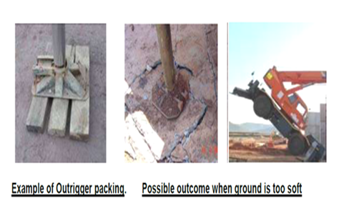 **Finger 3**

|  |  |  |
| --- | --- | --- |
| NO | Action | Responsibility |
| 1 | The other operating factors to consider during set-up include:  1. Can the crane get on site?  2. Is there room for the crane to manoeuvre?  3. What will the maximum operating radius be?  4. What obstacles or risks might be posed by existing buildings or structures | Rigger |
| 2 | All crane hooks will be fitted with positive locking safety catches. Safety catches is designed and positioned in such a way as to prevent the unintentional dislodgement of the suspended load from the hook. These units are exposed to severe punishment in the normal line of duty due to the hooks being bumped and dragged in normal operations thus sustaining heavy wear and tear. Maintenance of these units will be scheduled to ensure that they are always in good working order. | Rigger |
| 3 | A large shackle will be used to connect the sling to the hook. Provided (if applicable) lifting sling to be used has an eye or master link than a shackle will not be used. The shackle will be of adequate diameter to physically stop the safety catch from opening and causing roll out | Rigger |
| 4 | FRC machine specifications provided in Appendix 7.0.  Finger 4 | Rigger |
| 5 | All cranes and lifting equipment will be identifiable with a unique identity code and its rated capacity will be visibly displayed. | Rigger |
| 6 | All equipment involved in lifting operations to be issued with an identity number and documented on a register to facilitate the inspection and maintenance program and monitoring of compliance. | Rigger |
| 7 | The safe working load (SWL) will be clearly identified and marked on all cranes and relevant lifting equipment and will not be exceeded (figure 5). | Rigger |
| 8 | The mass of all equipment suspended from a hook, when added together, must not exceed the safe working load (SWL). This includes shackles, slings, lifting beams, and the item being lifted. The mass of all components must be known prior to commencing any lift. | Rigger |

Note: The only time when the SWL is exceeded on purpose, is when statutory load testing is undertaken by an appropriately qualified person/s.

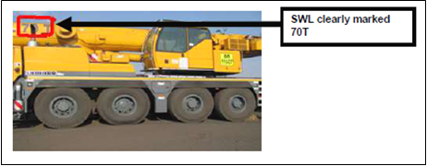

**Finger 5**

|  |  |  |
| --- | --- | --- |
| No | Action | Responsibility |
| 1 | All cranes will have Safe and practical access to perform pre-start checks, lubrication checks, maintenance checks and any other routine and non-routine work that may be required in the normal operation of the machine. | Rigger |
| 2 | Safe access and exit in terms of working at heights will be provided | Rigger |

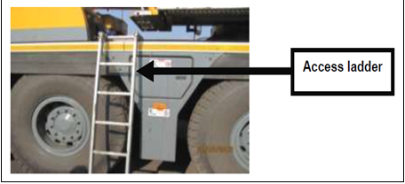

5.0 Suspension of a person by Crane

|  |  |  |
| --- | --- | --- |
| No | Action | responsibility |
| 1 | A Pre-use inspection will be performed on the cage or basket as well as all attachments prior to any person being suspended from a crane hook. The use of the man cage or work basket will be limited to those situations where it is necessary to elevate personnel to carry out work where it is not possible to use any other appropriate method. The use of a man cage or work basket will be in accordance with GLD 010 – Working at Heights. A Man cage or work basket Permit will be completed. | Rigger |
| 2 | Personnel will not use a crane hook as an anchor point for harness. | Rigger/Assistant |
| 3 | A recovery plan will be developed to allow for extraction of personnel in the event of a crane failure for any operation that requires suspension of personnel by crane. | Rigger/Assistant |
| 4 | A man cage or work basket will comply with the following:  • A gate with proper locking means.  • The Safe Work Load of the cage, including number of persons and weight of tools indicated on label.  • Fall protection equipment (Harness) must be used when using a man cage or work basket.  • Proper lugs for lifting by crane and harness hooks need to be provided.  • Must be inspected and certified by appointed engineer. | Rigger/ Assistant |

**6 Suspension of person by Manitou**

|  |  |  |
| --- | --- | --- |
| No | Action | Responsibility |
| 1 | Pre-start and pre-use checklists will be done, before person will be suspended from a Manitou when accommodated on a suitable work basket or cages | Operator/ Rigger |
| 2 | According to manufacture (OEM) standard. The use of Manitou will be in accordance with GLD 010.4 Safety. | Operator/ Rigger |
| 3 | The work basket or cages will indicate a maximum weight or number of person/s with tools included, to be suspended with a limit switch | Operator/ Rigger |
| 4 | The operator will blow the horn three (3) times to warn the person/s in the cage of his/her intended lifting. The Manitou will only operate on dry surface of not more than 15 degrees. The park brake will be applied, and outriggers must be out and locked. | Operator/ Rigger |
| 5 | Only a competent operator is allowed inside operator’s compartment. | Operator/ Rigger |
| 6 | The load will not be lifted with one fork only. Always tram with the forks in a fully tilted position and lower them when the machine is parked. | Operator/ Rigger |

**7.0 FRC Compliance on Equipment suspension of persons by Manitou**

|  |  |  |
| --- | --- | --- |
| No | Action | Responsibility |
| 1 | The following rules apply to cranes or Manitou’s supplied from outside companies or new equipment: | Operator and Rigger |
| 2 | All Crane or Manitou’s and Lifting equipment will be inspected prior to mobilisation to site by a competent person. The compliance forms will be completed and signed off by the relevant superintendent. A license disk will be issued and must be displayed in the crane at all times. | Operator and Rigger |
| 3 | When on site all cranes will abide by Kalagadi Mine Traffic Management Plan when not being used for lifting. | Operator and Rigger |

**8.0 Equipment**

|  |  |  |
| --- | --- | --- |
| No | Action | Responsibility |
| 1 | All plant and lifting equipment will comply with:  • Manufacturer’s procedure safety requirements | Engineering |

**9. Modifications**

|  |  |  |
| --- | --- | --- |
| No | Action | Responsibility |
| 1 | No modification to Cranes or Manitou’s and lifting equipment will occur unless management of change processes are followed as per Kalagadi Mine and approved by OEM and appointed engineer |  |

**9.10 Crane or Manitou Maintenance**

|  |  |  |
| --- | --- | --- |
| No | Action | Responsibility |
| 1 | All Cranes or Manitou’s will have a maintenance program and maintenance records. The records will be available at all times upon request. | Engineering |
| 2 | A risk assessment will be performed prior to commencing any maintenance activities. | Engineering |
| 3 | Where maintenance has been performed, a preoperational test will be performed to test if the maintenance performed has been successful | Engineering |
| 4 | Maintenance will only be performed by personnel qualified in the field of the repairs to be effected. OEM approved parts will be used where possible | Engineering |

**910 Crane or Manitou Maintenance**

**Appendix 1.0 Document Revision Control**

|  |  |
| --- | --- |
| **Document Revision Control** | |
| **Change Effected** | **Date of Issue** |
| New document | February 2018 |
|  |  |

**Appendix 2.0 References**

* Mine Health and Safety Act (Act 29 of 1996)
* Minerals Act (Act 50 of 1991)

**Appendix 3.0 Definitions and Abbreviation**

|  |  |
| --- | --- |
| Terms | Description |
| Contrast | The relative difference in luminance between two adjacent surfaces. In other words, how bright one surface looks compared to the other or to the background against which it is being viewed. |
| Colour corrected | Means the reading is corrected for the sensitivity of the human eye. |
| Cosine corrected | Means the reading will not be affected by holding the sensor area atan angle to the light flux i.e. light falling on the sensor at oblique angles. |
| Eav(Average illuminance | Arithmetic average of a series of illuminance measured at a specific number of points spread evenly over an illuminated area |
| Eh(Horizontal illuminance | Illuminance value measured with a photo-cell held in a horizontal position on a given surface. |
| Ev(Vertical illuminance) | Illuminance value measured with a photo-cell held in a vertical Position on a given surface. |
| Illuminance | It indicates how much light (in Lumens) would strike a surface area of one square meter (incident light), hence, Lumens/m2, and it is measured in Lux (SI unit). |
| Luminance | The amount of light reflected from a surface. The unit of measurement is candela per square meter (cd/m2). |
| Luminaire | A light fitting which supports a lamp and provides it with electrical connections. |
| Lux | The SI Unit for measuring illuminance |
| Visual environment | All portions of the visual field, including the visual task |
| Visual task | Those details, objects and their immediate background that have to be visible for the performance of a given task. |
| DMR | Department of Mineral Resources |

|  |  |
| --- | --- |
| Term | Description |
| Eav | Average illuminance |
| Eh | Horizontal illuminance |
| Ev | Vertical illuminance |
| GLD | Group Level Document |
| HSEC | Health, Safety, Environment and Community |
| MHS Act | Mine Health and Safety Act (Act 29 of 1996 |
| OEL | Occupational Exposure Limit |
| OHH | Occupational Health and Hygiene |
| OLD | Operation Level Document |
| SOP | Standard Operating Procedure |
| TMM | Trackless Mobile Machinery |